Strayer University

ACCESS CONTROL SYSTEM

Week 4

Case Study Assignment

for the

Course of
Systems Analysis and Development
05/01/17

By
Kennedy Kabaso.
Professor: Irene Hoskins.
ACCESS CONTROL SYSTEM

About the Access control System
Access control is a security technique that can be used to regulate who or what can view or use resources in a computing environment. Access control systems is the way of performing an authorization identification, authentication, and accountability of entities using a Pin number or other login methods. Access control can be of physical, which controls access to the compass buildings, rooms and Computers and can be of Logical, which controls access to computer networks, system files and data. On this project, a lots of security features will be added to conduct access on the compass into the student’s dormitory. Students will be given access into their dormitory using an access control system (ACS). This will be achieved using an electronic proximity reader where they can scan their card or badger, which will unlock the dormitory doors automatically. In addition, the will be cameras which are designed to face and rotate to record a person as they use their identification card to unlock the door. The card reader sends the data of the person to an intelligent door controller which contains stored programming information from the access control software about who is allowed in the dormitory and at what time. The project will give the College the ability to control, manage and monitor the access of each students and staff inside the dormitories.

Project Scope Statement
The project scope is the Access Control System will automatically open the Students dormitory doors with an electronic proximity reader and integrate with an existing security camera system.

Five Tasks
The project is going to be done in four different levels and broke down the levels into tasks and subtasks which would make it easy to understand.
Level 1, How to prepare this operation.
(1) Recruited people to do the tasks.
(a) ACS personal
(b) The Construction personal.
(2) Take a tour of the College Dorm
(a) Control Panel Installation Place.
(b) Reader’s installation wall.
(c) Camera’s installation wall.
(3) Create a design of the ACS
(a) Visual Diagram of College Exterior Dorm
(b) Visual Diagram of College Interior Dorm
(c) Visual Diagram of College Front Dorm
(4) Investigate Current Security System-ACS will be integrated with the current security system.
(a) Test the Cameras to make sure they are working.
(b) Compatibility with new ACS
(5) Make a Proposal to the Management.
(a) An estimate cost of the whole equipment’s and materials needed.
(b) An estimate cost of the Labor to do the project.
(c) How long it is going to take in terms of time.
Level 2, How to install
(A) Control Panel, which will be used to control the system.
(B) Wires, which will be used for connecting the whole system.
(C) Reader’s on the Front Wall, which will be installed on every front entry to the dorms.
(D) Reader’s on Exterior Walls, which will be installed on exteriors walls of the dorms.
(E) Cameras, which will be needed to face the readers.
(F) Reader’s on Interior Walls, which will be installed on every interior wall of the dorms
Level 3, How to Configure the system.
(A) ACS server-ACS software will be installed to contain the database. The readers and camera is going to be connected to the server to compare the credentials entered from card vs the Access Control List.
(B) Program Student ID’s to grant access. import that information into the ACS server for the Access Control List.
(C) Add all user names to the LDAP and RADIUS verification process on the secure server
Level 4, How to carry out the Test
(1) Transition Period-After doing the Installation and Configuration, testing is going to be done a couple of times before the system is full deployed.
(2) Soft-Deployment-Test run on the equipment with Staff members.
(3) Announcements-Notify all residents and staff about the new system and changes to the current process.
(4) Full Deployment-Activate ACS and Distribution of Access Cards.
I have put the whole process in a form of a diagram using a flow Cart below.
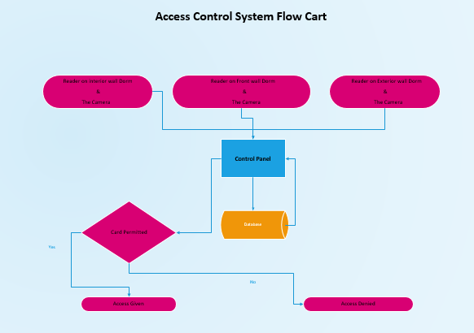
I have put everything about the task in a Gantt cart below. The Gantt cart shows how long the tasks are going to take. The duration of tasks are in weeks as you can see from the cart.

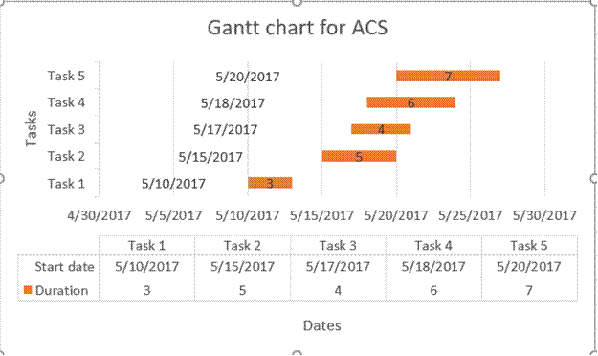

Bibliography
- http://www.securitymagazine.com/articles/84074-how-to-build-a-complete-access-control-system
- https://www.google.com/#q=what+is+an+Access+Control+Systems
- http://www.maglocks.com/cobra-controls-acp-1n-1-door-computerized-access-control-system-kit-by-cobra-controls-for-1559.html
- https://en.wikipedia.org/wiki/Access_control

